**prodisc Total Disc Replacement -**

**An Alternative to Cervical Fusion**

# Neck and Cervical Spine Anatomy

The vertebral bodies encase the spinal cord to provide protection. When stacked on top of each other, they form the spinal column which provides stability for the head and upper body. The spinal cord and the nerve exits are located within the spinal canal.

The intervertebral discs are located between the vertebral bodies. These discs cushion shock forces, acting as “shock absorbers”. The discs in conjunction with the vertebral joints facilitate motion by turning, stretching and bending of the neck.

*Spinal cord inside*

*vertebral foramen*

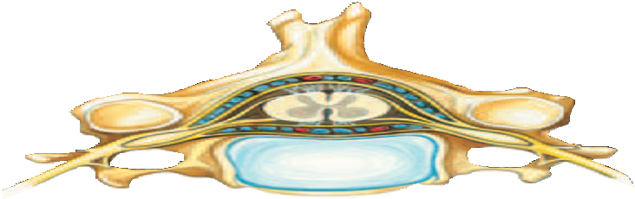

*Spinal nerve*

*Vertebral arch*

*Vertebral joint*

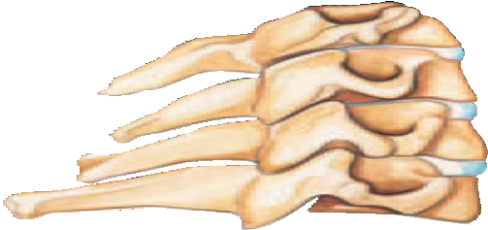

*Intervertebral disc Vertebral body*

# Degenerative changes of the spine

Degenerative changes of the spine occur from natural aging associated with pathological changes of the vertebral bodies, intervertebral discs, ligaments, and vertebral joints.

These changes can greatly limit both the **mobility** and **stability** of the spine.

The stability of the spine can also be compromised by unnatural weight distribution caused by a hereditary abnormality, or a lack of movement associated with a sedentary lifestyle. Any previous operation or trauma to the spinal column can also cause a loss of stability.

Any form of instability can progress to become a pain generator.

## Herniated Discs

The described degenerative changes or trauma can cause tears in the intervertebral disc. The escape of the nucleus (or soft interior) of the intervertebral disc outward through these tears may cause a disc herniation.

The disc herniation can impinge on the nerves and depending on the location can cause **pain in the neck, arms, and shoulders**. In the extreme case, it can cause **paralysis**.

# prodisc C System of Total Disc Replacement Devices

The treatment goal of the pro**disc** C Total Disc Replacement system is to restore the normal dynamic function of the spine and to significantly reduce pain.

The function of the spine is restored through the mechanism of action of the device. Pain reduction is achieved through the re-establishment of the disc height and maintained by the prosthesis. The increase in height and the elimination of the herniated disc “opens” constricted nerve paths and the vertebral joints are restored to their physiological position.

Prior to the development of artificial discs, the only surgical option was a fusion, in which adjacent vertebral bodies are “fused together” permanently using implants, bone chips and/or cages. The goal of the pro**disc** C Total Disc Replacement device is to **maintain mobility** at the affected intervertebral disc and to **reduce the extra loading** on the adjacent intervertebral discs.

**pro**disc **C Goals**

# Maintain Spinal Balance and Motion

Degenerative disc disease can destabilize segments over time. In addition, performing the surgical discectomy is inherently destabilizing, as it involves the removal of the Anterior Longitudinal Ligament, the disc, and often, the Posterior Longitudinal Ligament[1]. In the absence of these restricting structures, it is important for a disc replacement to have constraints in order to protect the facet joints.

In order to provide constraint, the pro**disc** mechanism of action enables movement with a fixed center of motion, enabling A/P translation only with flexion / extension[2],[3].

Above: Lateral Bending, Flexion / Extension, Axial Rotation.

Shown minimums for pro**disc** C Vivo; minimums vary by device selected to suit patient’s anatomy.

Controlled and Predictable Motion

* Allows a normal range of motion while providing segmental stability through controlled translation[4].
* Highly conforming surfaces of the superior endplate and UHMWPE inlay prevent the endplates from translating independently[5].
* Translation is provided by rotation of the superior endplate around the ball on the inferior endplate.

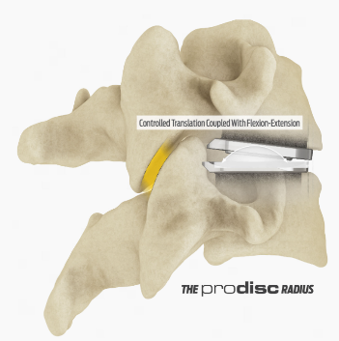Range of Motion



* The pro**disc** C Total Disc Replacement device is designed to allow for a normal range of motion in flexion /extension, lateral bending, and axial rotation.iv,[6],[7],[8],[9]*

* L5, LD5, XL5 and XLD5 sizes allow 17.5° in flexion / extension and lateral bending.

**Decelerate Adjacent Level Reoperations**

The historical treatment for degenerative disc disease is to

conduct an ACDF and fuse the joint. However, immobilizing a segment of the spine with a fusion has been shown to potentially increase the rate of adjacent-level degeneration[10]. By enabling motion, pro**disc** is intended to decelerate adjacent level degeneration. A paper published on the results with the US IDE PMA clinical studyx on pro**disc** showed that, at seven years follow-up, patients had four times fewer reoperations of adjacent segments, compared to patients that received an ACDFx.



**Range of Motion**

* The pro**disc** C Total Disc Replacement device is designed to allow for a normal range of motion in flexion /extension, lateral bending, and axial rotation.x
* Long-term prospective randomized multi-center evidence illustrates that patients retained range of motion of 8.12° for 7 years.x
* Fusion patients from the study had a range of motion of 0.66°.x

# Accelerate the Resumption of Activities of Daily Living

The operative procedure to conduct a discectomy can be invasive and require recuperation. Special care has been taken to design the technique and instrumentation to minimize the recovery associated with the procedure. A review of nearly 7,000 patients in the Blue Health Intelligence Claims Database showed that patients who received a pro**disc** C device experienced significantly shorter length of hospital stays compared to patients who received an ACDF.2

**Immediate & Long-Term Implant Fixation**

* The pro**disc** C Total Disc Replacement device is intended to provide immediate stability by itself through the design of the keel and/or bone spikes.
* Over the long-term, the pro**disc** design intent is to provide an opportunity for bone to grow onto the rough, porous surface of the implant, providing additional stability.

2 MCRA, MCRA break-down of Blue Health Intelligence Data: ACDF vs. Cervical Disc Arthroplasty Outcomes, 2012.Results on file at DePuy Synthes Spine. Data available upon request.

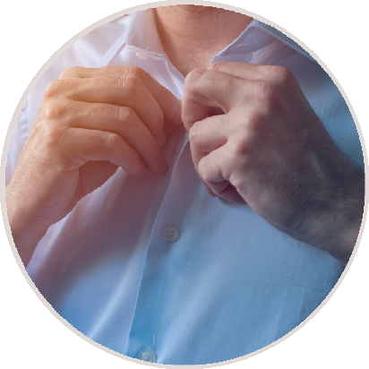

## prodisc Cervical Design

There are four different pro**disc** Cervical Total Disc Replacement devices, each with different designs and consists of two metal plates[11] with a titanium coating that allows for bony ingrowth of the prosthesis[12],[13],[14],[15],[16]. A plastic core (polyethylene) located between the plates guarantees the mobility in the segment (ball and socket joint principle). All of these materials are clinically proven to be tolerated very well by the body. This design prevents overloading of the adjacent intervertebral discs, as can occur after traditional spinal fusion.

Different sizes of the pro**disc** C Total Disc Replacement device are available to the surgeon, so that he can select the correct size of prosthesis that fits best with your anatomy.

## Anchorage of the prosthesis

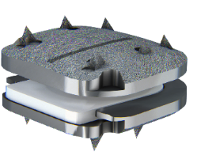To achieve short-term, primary stability directly after the operation, the pro**disc** C Vivo intervertebral prosthesis is equipped with six lateral spikes on the upper and lower endplates that are anchored directly into the vertebral body. The necessary stability is thus achieved immediately upon implantation.

Other pro**disc** C Total Disc Replacement devices use keels to provide immediate fixation of the prosthesis.

In addition, all pro**disc** C Total Disc Replacement devices have the entire bone-facing surface coated with a highly porous pure titanium layer which facilitates the growth of bone on the metal components due to its extremely rough and porous surface.

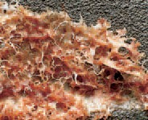

**pro**disc **Clinical History**

The pro**disc** technology has a long clinical history (30+ years) and has been widely used throughout the world. The pro**disc** technology is one of the most proven and studied total disc replacements in the world, with over 30 years of global use, 540 peer-reviewed published studies[17], and 250,000 implantations[18]. The first implantation of a cervical pro**disc** device took place in 2002 – with US PMA approval following in 2007.

pro**disc is manufactured and distributed by:**

**CENTINEL SPINE, LLC**

900 Airport Road, Suite 3B West Chester, PA USA 19380 Tel: 484.887.8810

Fax: 800.493.0966

[info@centinelspine.com](mailto:info@centinelspine.com) [www.centinelspine.com](http://www.centinelspine.com/)

Centinel Spine® and prodisc are registered trademarks of Centinel Spine, LLC

MKT-0079 Rev 2 Sept 2024

1. White A, Panjabi M, Clinical Biomechanics of the Spine, Lippincott, 1990.
2. Pearcy M, Portek I, Shepherd J, Three-Dimensional X-ray Analysis of Normal Movement in the Lumbar Spine, Spine Vol 9, 3, 1984.
3. Bertagnoli, R., Marnay, T., Mayer, H.M., The PRODISC Book, 2003.
4. DiAngelo DJ, et al. In Vitro Biomechanics of Cervical Disc Arthroplasty with the ProDisc-C Total Disc Replacement. Neurosurg Focus. 2004 Sept 15;17(3):E7.
5. Sears, R., et al., Kinematics of Cervical and Lumbar Total Disc Replacement, Semin Spine Surg, 2006, 18:117-129.
6. Zhao YB, et al., Cervical disc arthroplasty with prodisc-C artificial disc: 5-year radiographic follow-up results. Chin Med J (Engl). 2013 Oct; 126(20):3809-11.
7. [Lou J](https://www.ncbi.nlm.nih.gov/pubmed/?term=Lou%20J%5BAuthor%5D&cauthor=true&cauthor_uid=27130391), [Li H](https://www.ncbi.nlm.nih.gov/pubmed/?term=Li%20H%5BAuthor%5D&cauthor=true&cauthor_uid=27130391), [Rong X](https://www.ncbi.nlm.nih.gov/pubmed/?term=Rong%20X%5BAuthor%5D&cauthor=true&cauthor_uid=27130391), [Wu W](https://www.ncbi.nlm.nih.gov/pubmed/?term=Wu%20W%5BAuthor%5D&cauthor=true&cauthor_uid=27130391), [Liu H](https://www.ncbi.nlm.nih.gov/pubmed/?term=Liu%20H%5BAuthor%5D&cauthor=true&cauthor_uid=27130391). Location change of center of rotation after single-level cervical total disc replacement with ProDisc-C. [Acta Orthop Traumatol Turc.](https://www.ncbi.nlm.nih.gov/pubmed/27130391) 2016;50(3):339-45.
8. Colman M, Zavras A, Federico V, Nolte M, Butler A, Singh K, Phillips F. Longitudinal assessment of segmental motion of the cervical spine following total disc arthroplasty: a comparative analysis of devices. J Neurosurg Spine. 2022 Apr 15;1-7.
9. [Park JJ](https://www.ncbi.nlm.nih.gov/pubmed/?term=Park%20JJ%5BAuthor%5D&cauthor=true&cauthor_uid=20354472), [Quirno M](https://www.ncbi.nlm.nih.gov/pubmed/?term=Quirno%20M%5BAuthor%5D&cauthor=true&cauthor_uid=20354472), [Cunningham MR](https://www.ncbi.nlm.nih.gov/pubmed/?term=Cunningham%20MR%5BAuthor%5D&cauthor=true&cauthor_uid=20354472), [Schwarzkopf R](https://www.ncbi.nlm.nih.gov/pubmed/?term=Schwarzkopf%20R%5BAuthor%5D&cauthor=true&cauthor_uid=20354472), [Bendo JA](https://www.ncbi.nlm.nih.gov/pubmed/?term=Bendo%20JA%5BAuthor%5D&cauthor=true&cauthor_uid=20354472), [Spivak JM](https://www.ncbi.nlm.nih.gov/pubmed/?term=Spivak%20JM%5BAuthor%5D&cauthor=true&cauthor_uid=20354472), [Goldstein JA](https://www.ncbi.nlm.nih.gov/pubmed/?term=Goldstein%20JA%5BAuthor%5D&cauthor=true&cauthor_uid=20354472). Analysis of segmental cervical spine vertebral motion after prodisc-C cervical disc replacement. [Spine (Phila Pa 1976).](https://www.ncbi.nlm.nih.gov/pubmed/20354472) 2010 Apr 15;35(8):E285-9.
10. Janssen ME, et al, ProDisc-C Total Disc Replacement Versus ACDF for Single-Level Symptomatic Cervical Disc Disease, JBJS, 2015, 97:1738-47.
11. Metal plate designs vary from device to device from country to country. See package insert for specific design information.
12. D.M. Brunette, P. Tengvall, M. Textor, P. Thomsen (Editors), “Titanium in Medicine”, Springer Verlag Berlin Heidelberg, 2001. Chapter 12: “Thermal Spray H. Gruner
13. Winkler-Gniewek W, Stallforth H, Ungethüm M, Gruner H (1988) “Structure and properties of VPS coatings in medical technology”. Vol. 3. Proc 1st Plasma-Technik Symp, Luzern, pp 95–102
14. Hoppe, Sven, et al. "First results of a new vacuum plasma sprayed (VPS) titanium-coated carbon/PEEK composite cage for lumbar interbody fusion." Journal of Functional Biomaterials 9.1 (2018): 23.
15. Rorabeck, C. H., et al. "Acetabular osteolysis with cementless cups: a 5 to 7 year follow-up." Acta Orthopaedica Belgica 63 (1997): 83-92.
16. K.Palka, R.Pokrowiecki, M.Krzywicka, Porous titanium materials and applications
17. Search performed on Pubmed, Embase, Ovid Medline® covering 1988 – 2024.
18. Data on file at Centinel Spine compiled from Spine Solutions, Synthes Spine, DePuy Synthes, and Centinel Spine.